# **User Guide**

Employee Database is very simple, user friendly database application which stores all of its data in external Mysql database. Application is aimed for medium and large companies to maintain the information in a ordered way with many feautures. In this guide we will see every possible step and solutions in the application.

**1.Login** - Login is very simple with username and password, by default - Username : admin

Password : admin, if there are some connection problems , it will be shown in the bottom label, also make sure that you are running on database and that table login has some data , by default Username : admin , Password : admin.

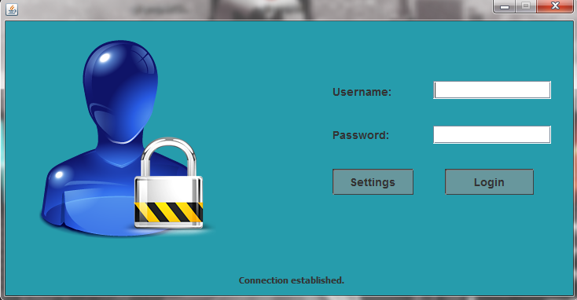

**2.Settings -** If your connection was not estabilished , you should check settings button

as you can see there are option such as bookmarks and connect, if bookmarks are empty you must create a new bookmark , this is done by clicking connect tab and filling up database connection information - Picture 3.

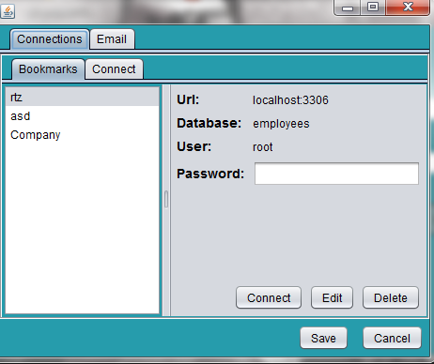

**3.Settings - Connect**

You should fill up the url and port where is database stored, also you must know the database name, your username , by default it is : root and password by default is blank.

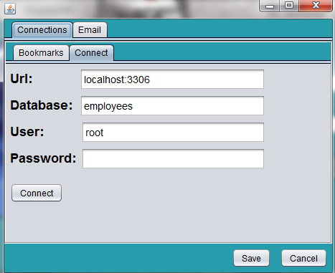

**4.Main screen**

If login was successful you wil get to the main screen of our application, as you can see there are 6 buttons. Refresh button is basically used for refreshing the employees table. 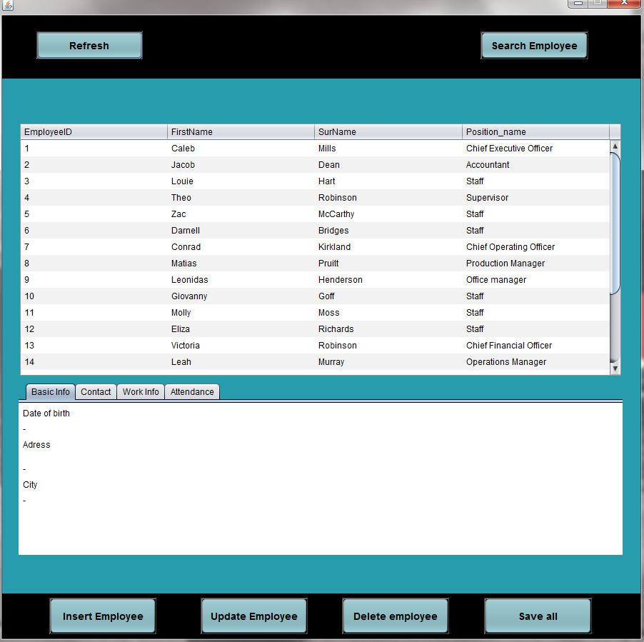

**5.Main screen - clicking the employee**

After click on some of the employees you get its information in the table which is below the employees table, to get additional info - such as contact, work info, attendance you must switch between the tabs.

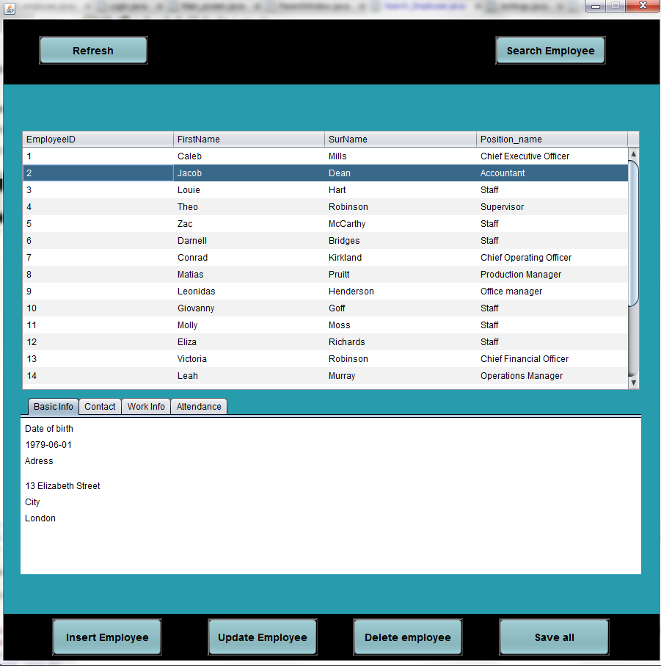

**6.Main Screen - Search Employee**

Here is the search screen which will appear after clicking the search employee button, you can search by the ID, name, surname or just gender of employee. You can search by every parameter or just one. After clicking Search you will be redirected on the employee table in the main screen.

If there is no result , you will get the warning.

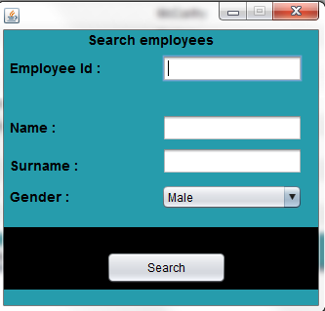

**7.Main screen - Insert new employee**

With this feature you can insert new employee into your database.

Information also contains the salary and wage per hour. If that things are not certain in a moment you can set 0 and update that information later as well.

Warning : Every field must be filled up to insert a new employee

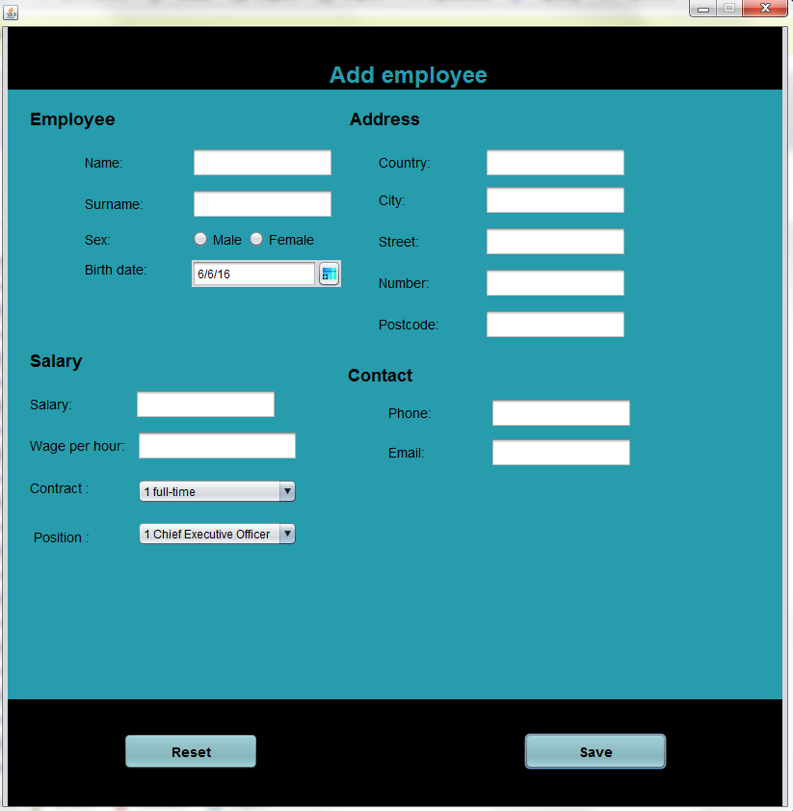

8.Main screen - Update existing employee

Here as you can see the application recieves the information about user that you have clicked on, if you did not click on some of the employees you will get the warning, here you can change information about employee.

It could be one thing or all of the information.

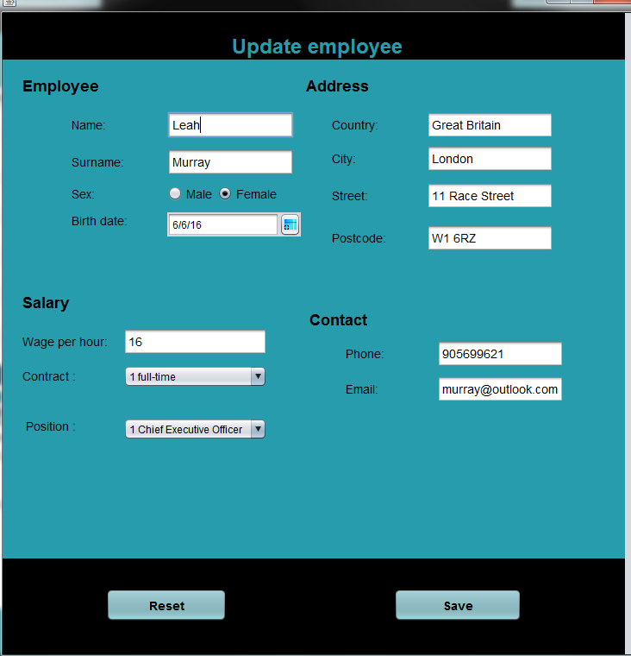

**9.Main screen - Delete employee**

Select the employee in the database you want to delete and confirm this action

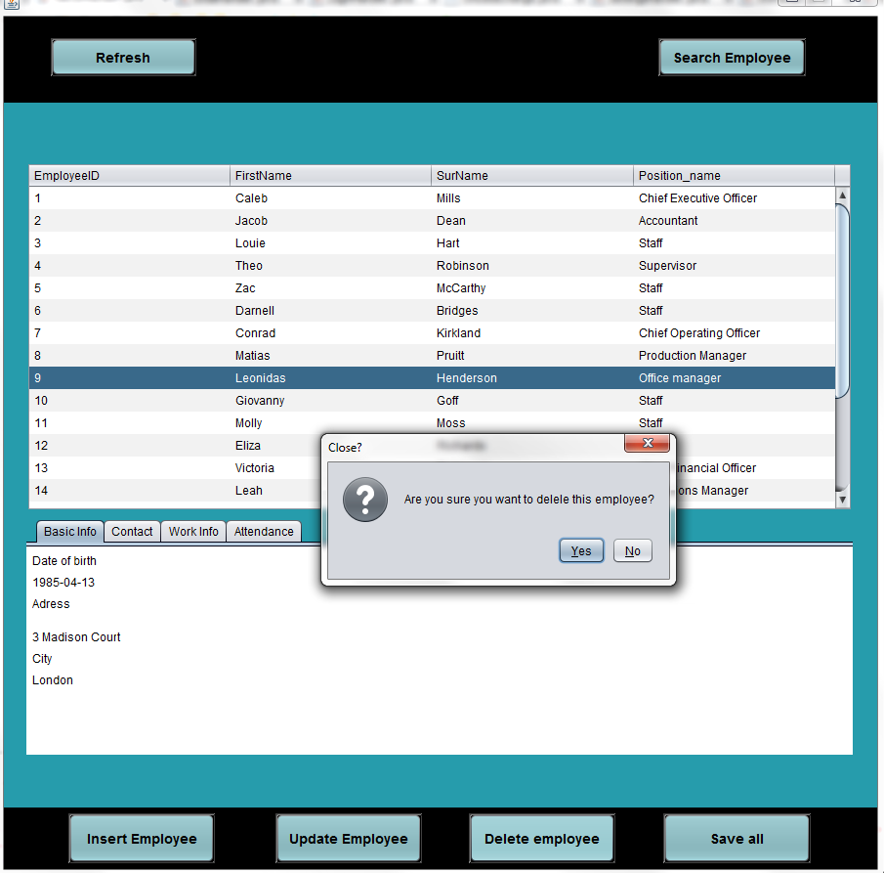

**10.Main screen - save**

This function saves all the information about employees

